This application provides a Graphic User Interface (GUI) for Stepper Motor Controller running in an Arduino Nano processor. The application reads azimuth and elevation data from the WSJT azel.dat file and passes it to the controller. WSJT must be running for the application to operate. The configuration file allows the location of the azel.dat file (set in WSJT setting /audio/azel.dat directory) to be specified. If the azel.dat file is not being updated the application will report a fatal error and stop.
The application is an extension of a PC time sync application, providing PC time sync from a GPS NMEA RMC sentence. The configuration file c:\azel.txt declares the serial ports for the controller and the GPS receiver. Instructions for configuring the ports are included as comments in the file. Example configuration with controller port only at the foot of this document.
An azel.dat simulator AZELSIM.exe, included in this publish package, will update the data file for testing. WSJT must not be running when the simulator is running.
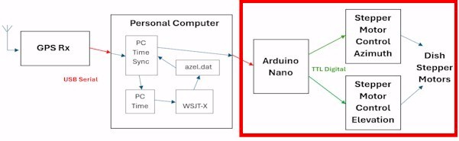
The application may be installed without Windows registration. Copy the TimeSync_and Tracking.exe file to a director on C:\. Install the azelcfg.txt into C:\. Check the com ports and azel.dat file entries match your environment. Install the .ocx files required for execution of the VB6 application in C:\Windows\System32 for a 32 bit machine or C:\Windows\SysWOW64 for 64 bit. The .ocx file names and how to download are in comments in azelcfg.txt.
When the application is run (run as administrator for time sync), the configuration is presented on a splash screen. This screen may be acknowledged (OK) else it clears after 5 seconds to the main GUI. Date of build is overlayed near the OK button.
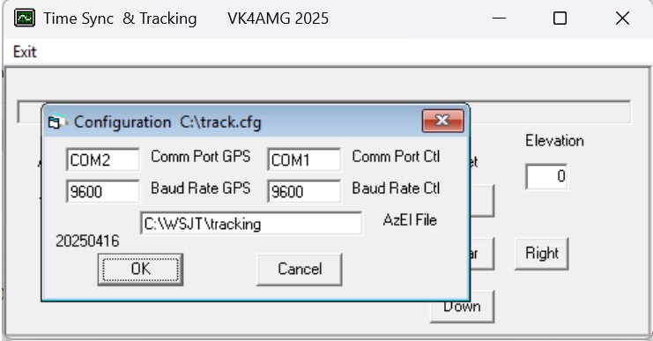
When the application starts and the comms port is opened, the Nano controller will be reset and run through its initialisation procedure of rotating to the limit switches and then homing to north and horizonal (0º, 0º) .
The GUI shows the NMEA RMC sentence (shows “GPS not used” if GPS port is not in the configuration).
The data read from the azel.dat file is displayed. If the elevation is negative, the Azim and Elev will be greyed out.
At 15 and 45 second of the local time, the command (azel.dat plus offset) is passed to the controller. “Track” LED flashes Red when command is passed to the controller then LED returns to green. The LED will be greyed out if there is an error in sending the command via the serial port.
The controller will move to the commanded azimuth and elevation.

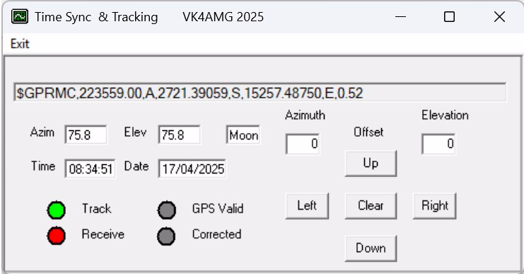

A function to allow offset entry for testing is provided by a set of buttons. The resulting offsets are shown on the GUI. The offsets may be zeroed by the Clear button. A command including the offsets is sent 1 second after the change.
The application may be closed via the Exit menu or the close ‘X’.

Questions / comments to VK4AMG@WIA.org.au

Configuration file azelcfg.txt
C:\WSJT\tracking
COM1
9600

// remove above spaces and this comment if GPS serial port is to be used.
COM2
9600
// Configuration notes
// 1. location of azel.dat file usually c:\WSJT
// 2. comm port for controller e.g. COM1
// 3. controller port baud rate usually 9600
// 4. comm port for GPS e.g. COM1
// 5. GPS port baud rate usually 9600
// if GPS is not used line 4 & 5 may be left blank null character not space
// if controller commands are fed via GPS line 2 and 4 have same entry
// Lines 6 on are not read.
//
// mscomctl.ocx and comctl32.ocx files, required for this VB6 application
// may be downloaded at //https://www.microsoft.com

